Nalongsone Danddank Student ID : 14958950 StarID: jf3893pd

Email: [nalongsone.danddank@my.metrostate.edu](mailto:nalongsone.danddank@my.metrostate.edu)\

**ICS 432 - 01 — Distributed and Cloud Computing Fall 2021**

**Lab #6 :** Networking and Load Balancing in GCP

Exercise 1: Multiple VPC Networks.

**Lab report screen-shot #1:**

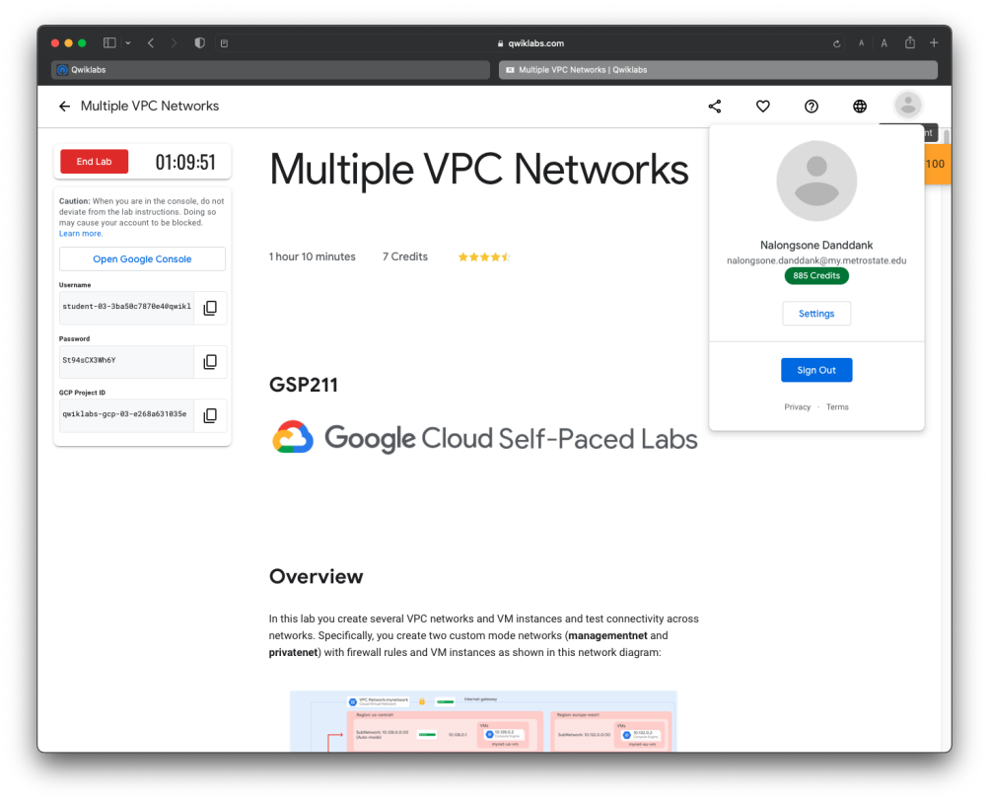

**Lab report screen-shot #2:**

**gcloud compute networks create managementnet --project=qwiklabs-gcp-03-e268a631035e --subnet-mode=custom --mtu=1460 --bgp-routing-mode=regional && gcloud compute networks subnets create managementsubnet-us --project=qwiklabs-gcp-03-e268a631035e --range=10.130.0.0/20 --network=managementnet --region=us-central1**

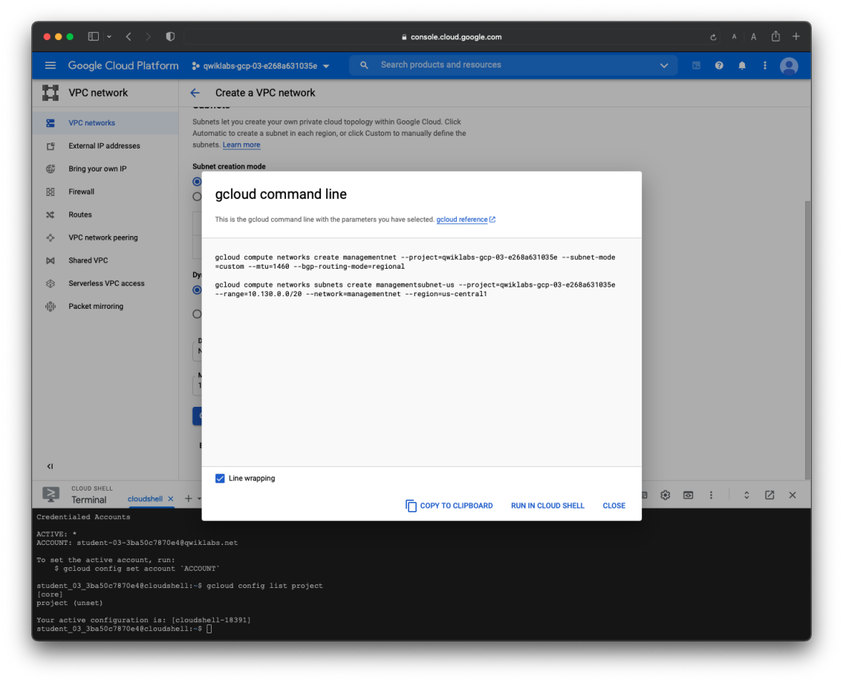

**Lab report screen-shot #3:**

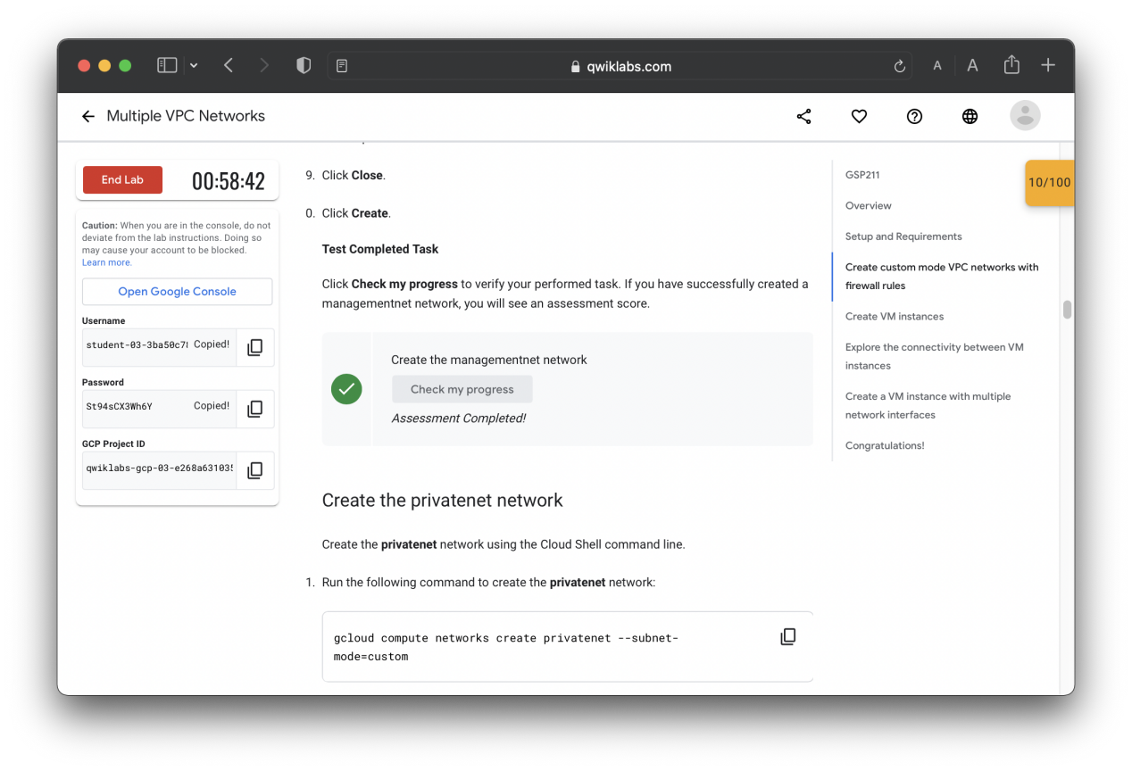

**Lab report screen-shot #4:**

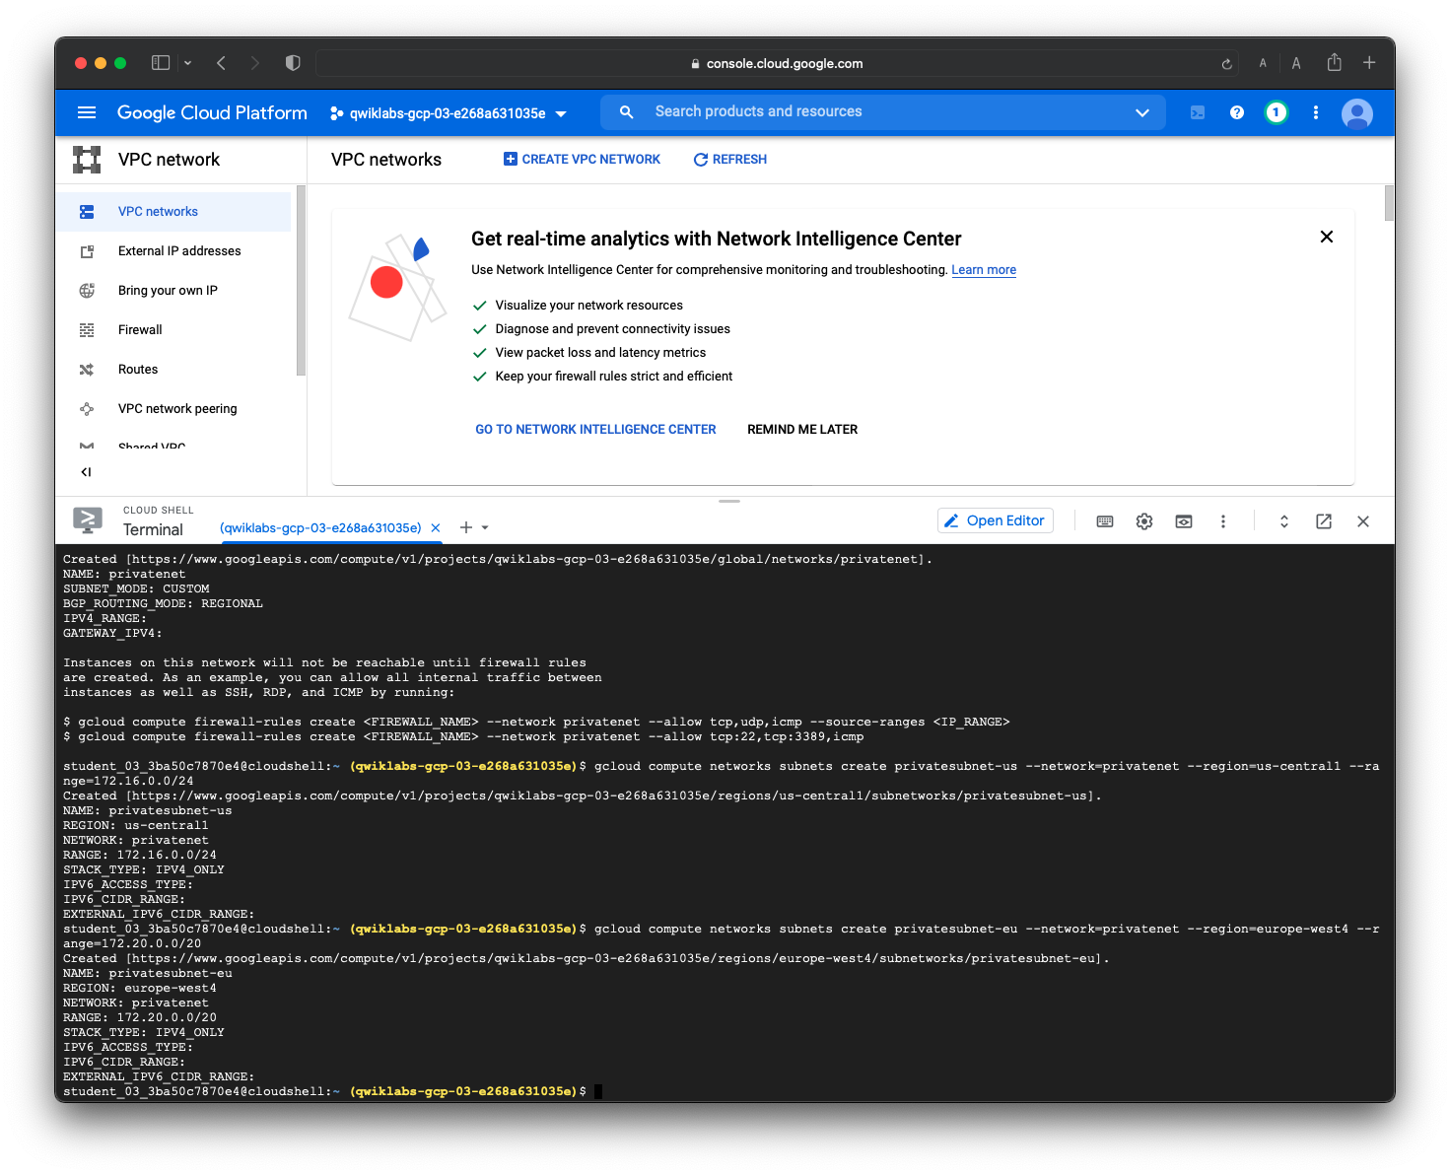

**Lab report screen-shot #5:**

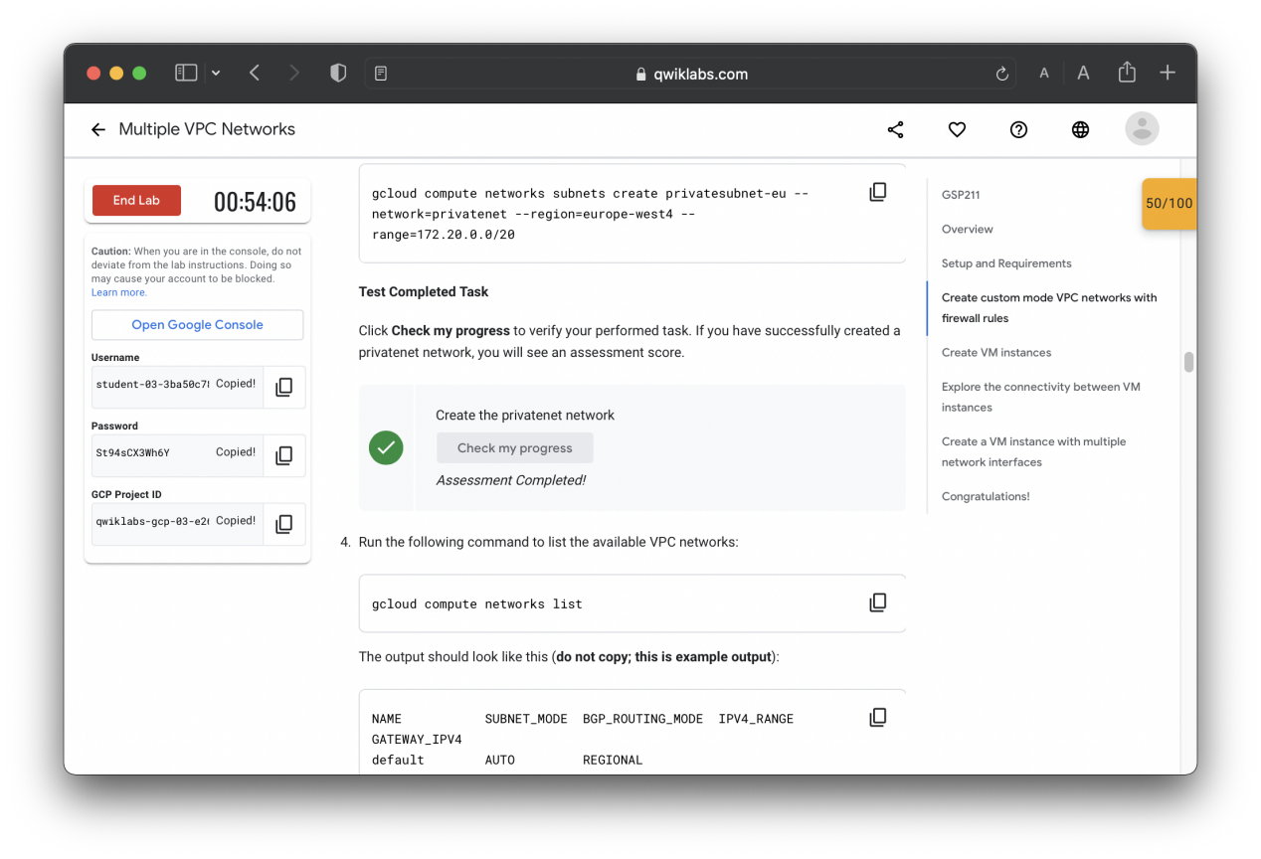

**Lab report screen-shot #6:**

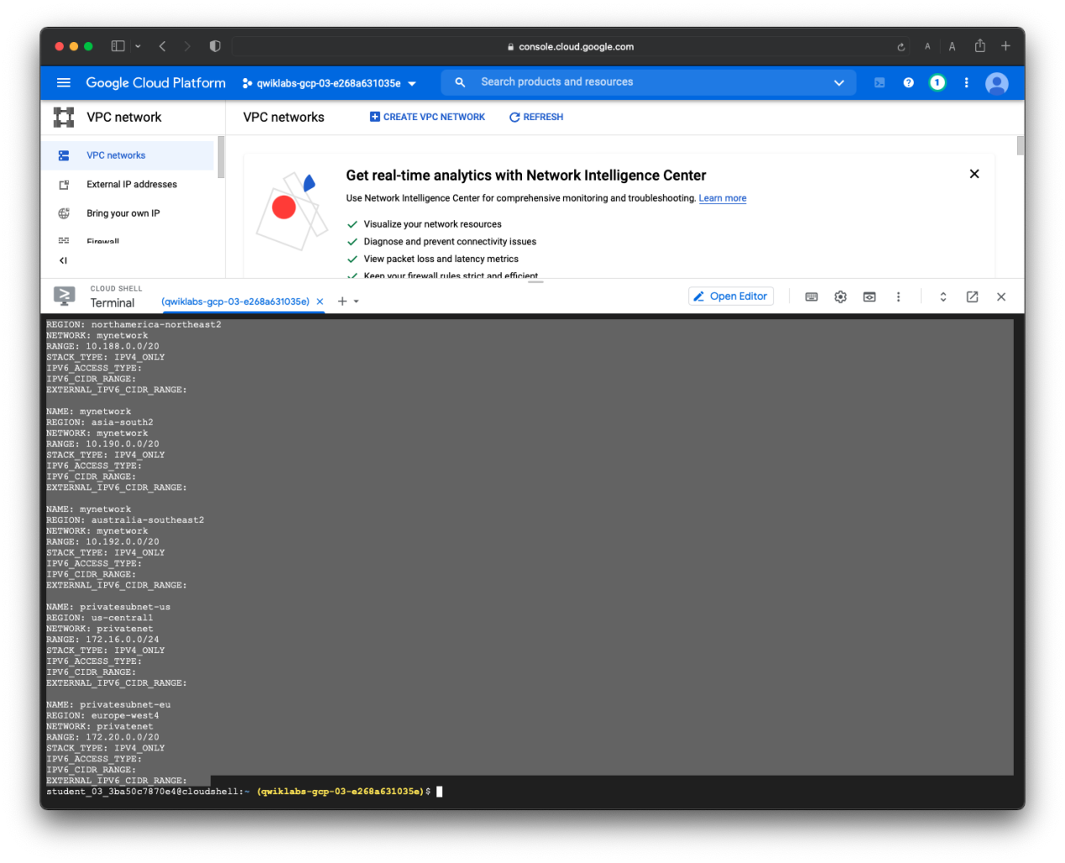

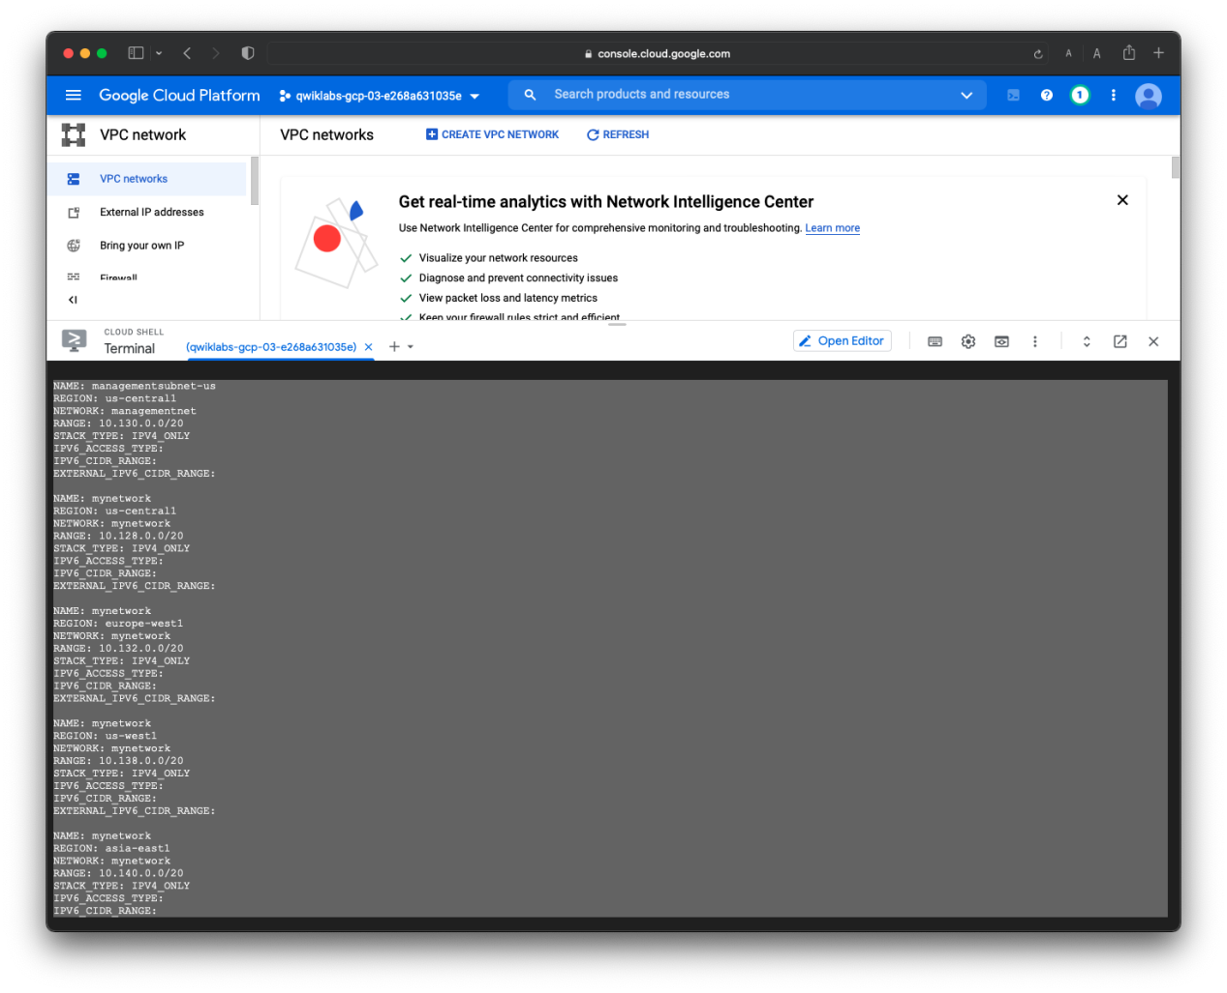

**Lab report screen-shot #7:**

**gcloud compute --project=qwiklabs-gcp-03-e268a631035e firewall-rules create managementnet-allow-icmp-ssh-rdp --direction=INGRESS --priority=1000 --network=managementnet --action=ALLOW --rules=PROTOCOL:PORT,... --source-ranges=0.0.0.0/0**

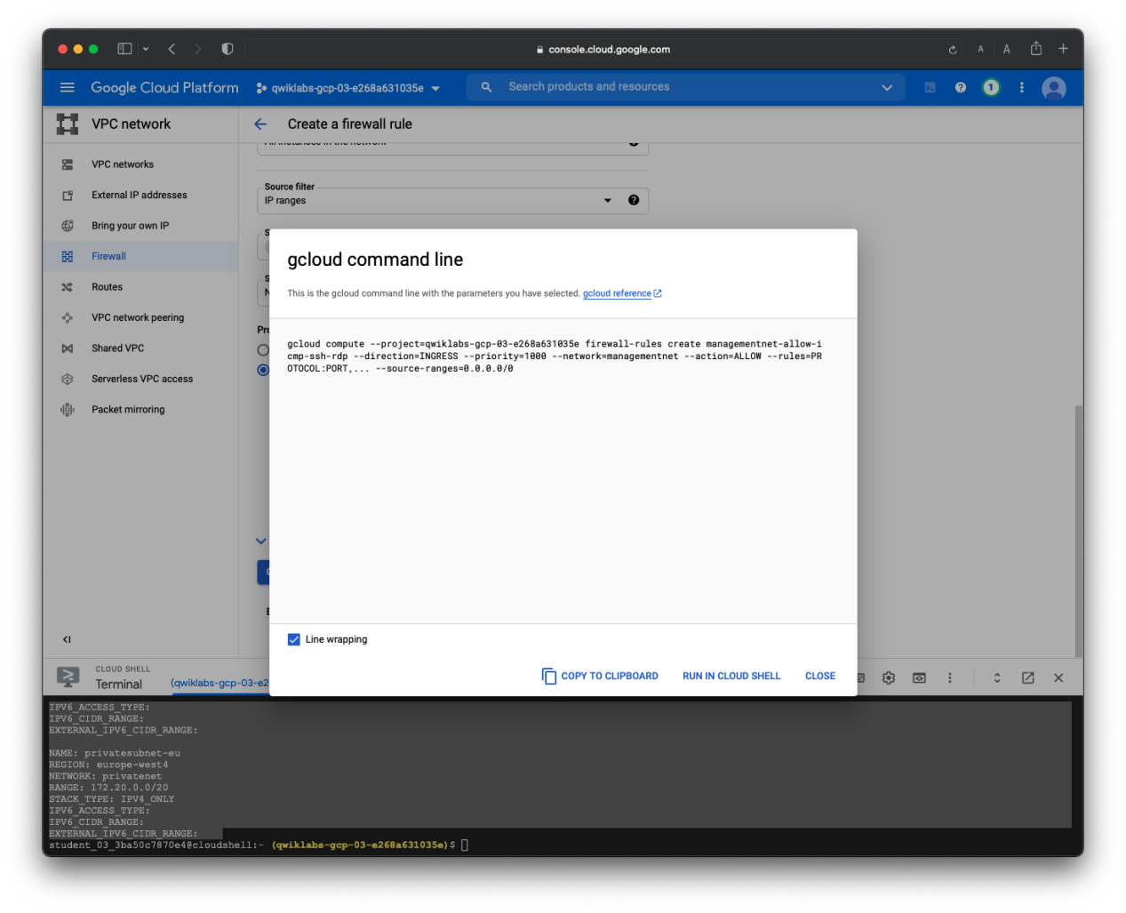

**Lab report screen-shot #8:**

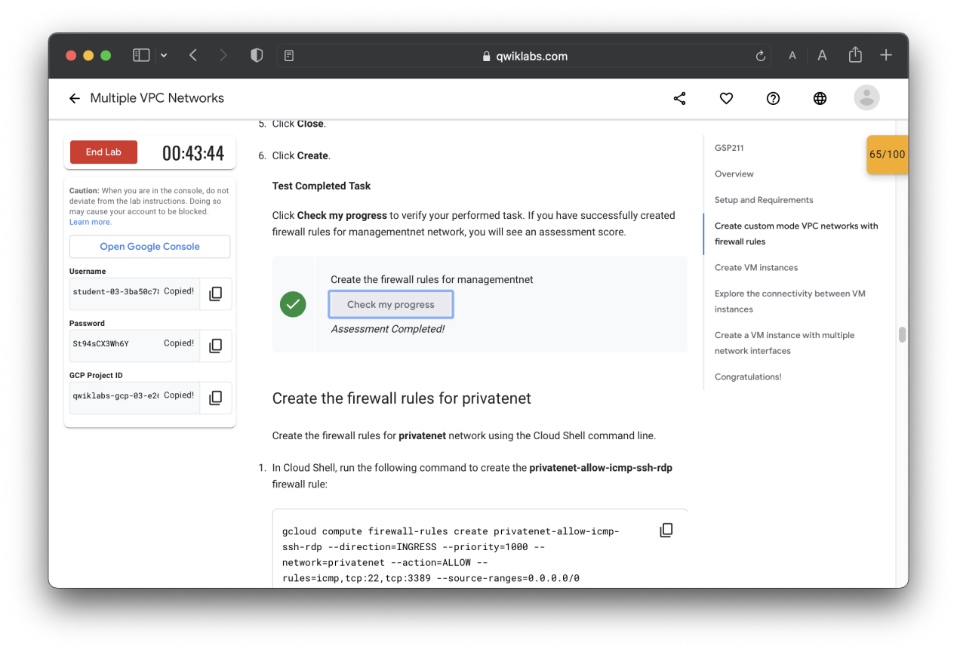

**Lab report screen-shot #9:**

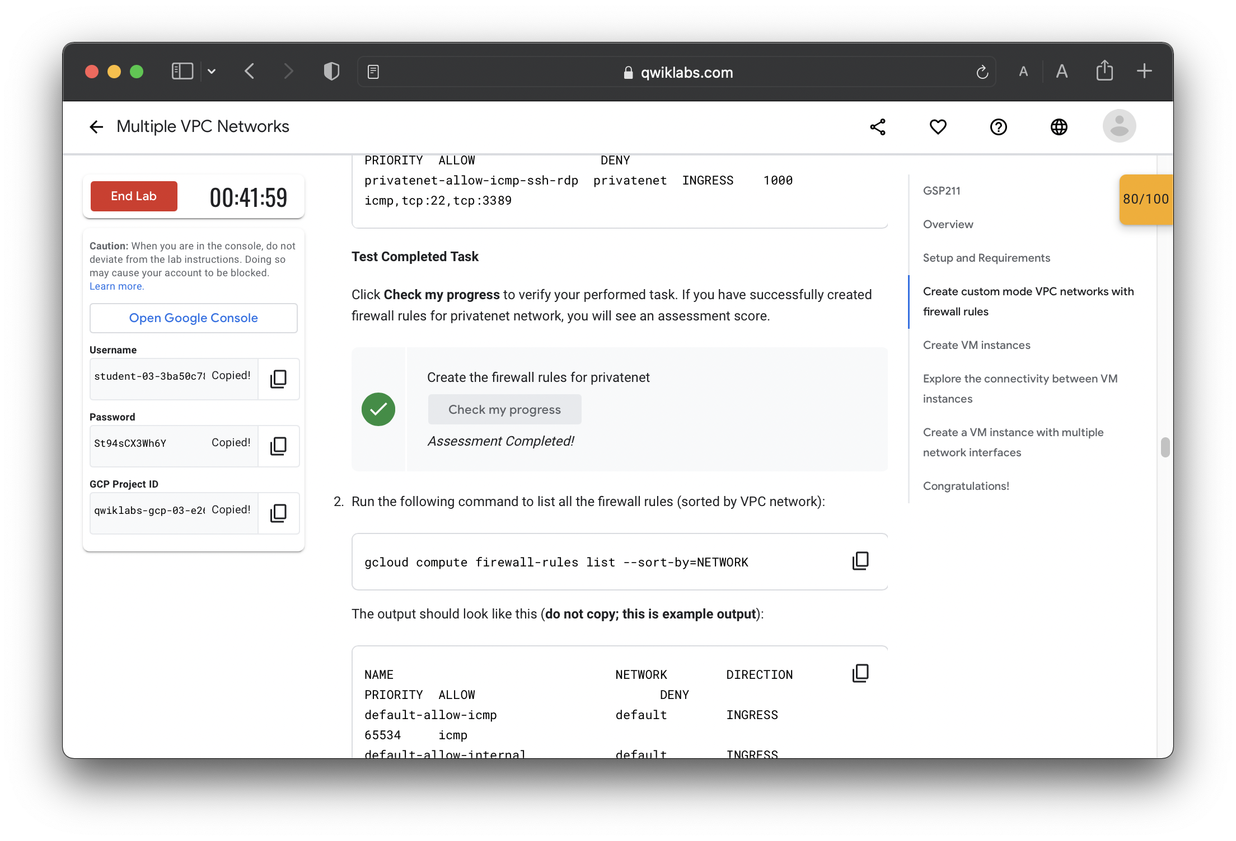

**Lab report screen-shot #10:**

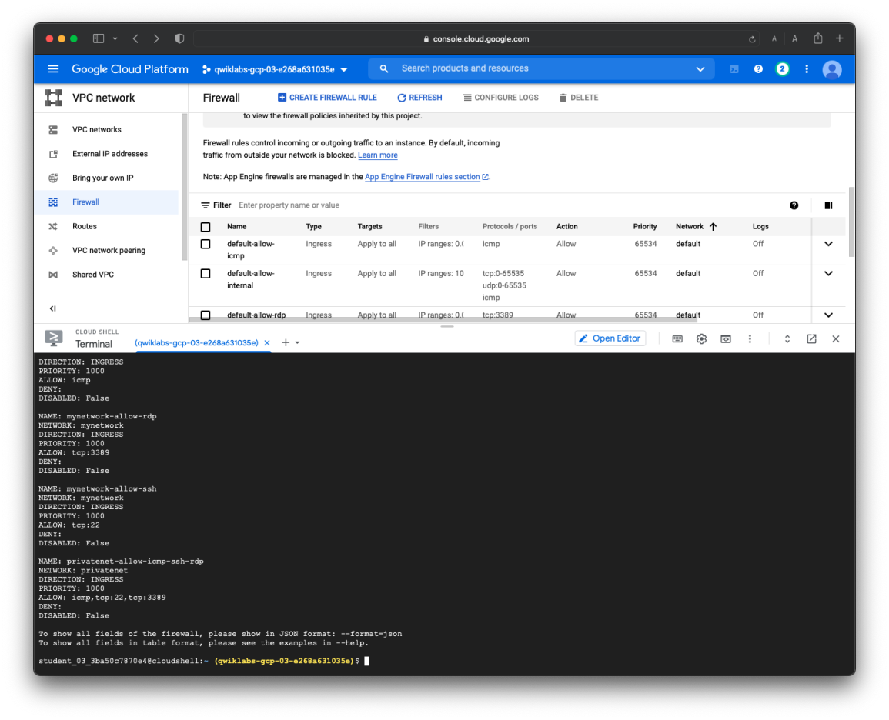

**Lab report screen-shot #11:**

**gcloud compute instances create managementnet-us-vm --project=qwiklabs-gcp-03-e268a631035e --zone=us-central1-f --machine-type=f1-micro --network-interface=network-tier=PREMIUM,subnet=managementsubnet-us --maintenance-policy=MIGRATE --service-account=330874370077-compute@developer.gserviceaccount.com --scopes=https://www.googleapis.com/auth/devstorage.read_only,https://www.googleapis.com/auth/logging.write,https://www.googleapis.com/auth/monitoring.write,https://www.googleapis.com/auth/servicecontrol,https://www.googleapis.com/auth/service.management.readonly,https://www.googleapis.com/auth/trace.append --create-disk=auto-delete=yes,boot=yes,device-name=managementnet-us-vm,image=projects/debian-cloud/global/images/debian-10-buster-v20210916,mode=rw,size=10,type=projects/qwiklabs-gcp-03-e268a631035e/zones/us-central1-f/diskTypes/pd-balanced --no-shielded-secure-boot --shielded-vtpm --shielded-integrity-monitoring --reservation-affinity=any**

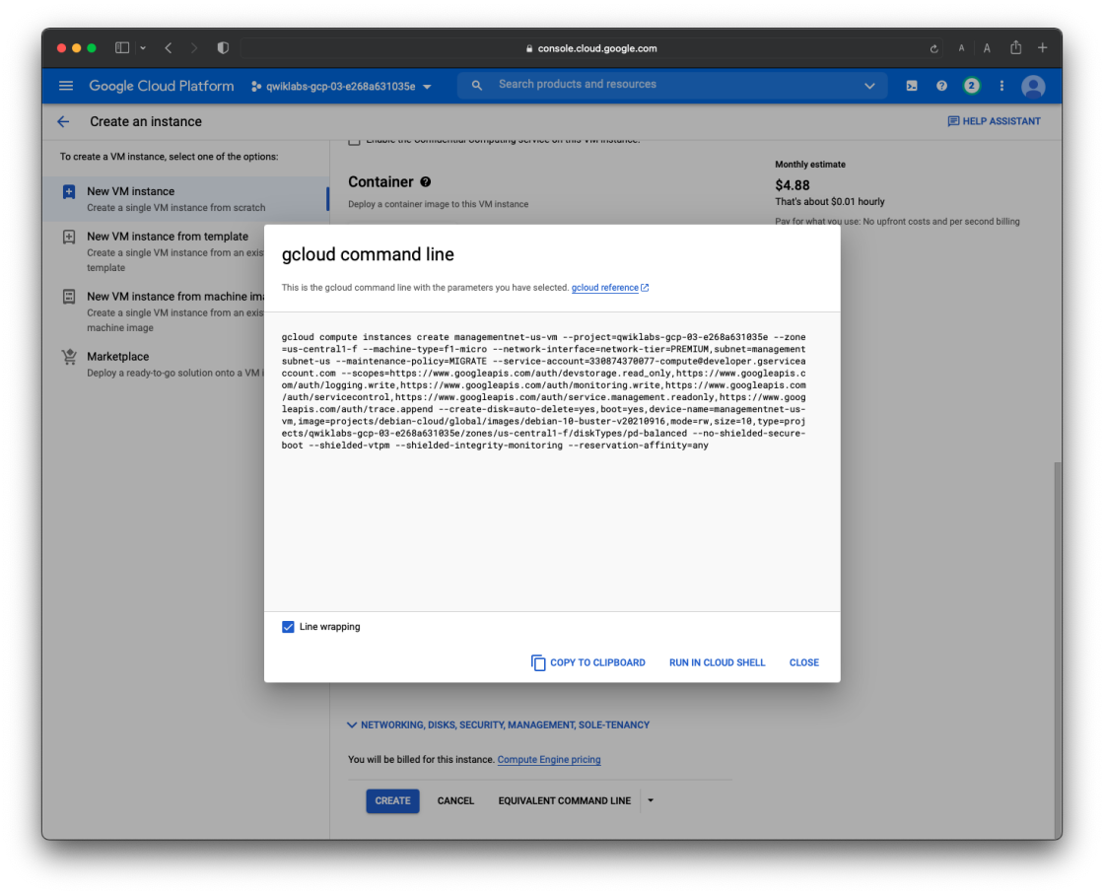

**Lab report screen-shot #12:**

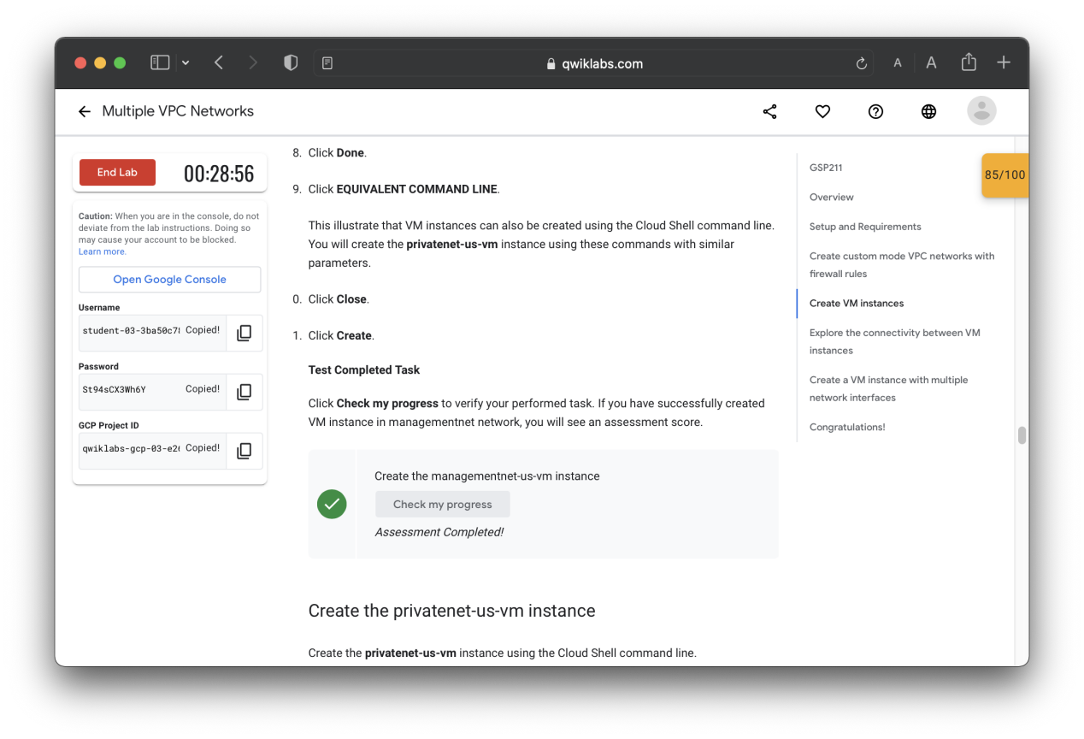

**Lab report screen-shot #13:**

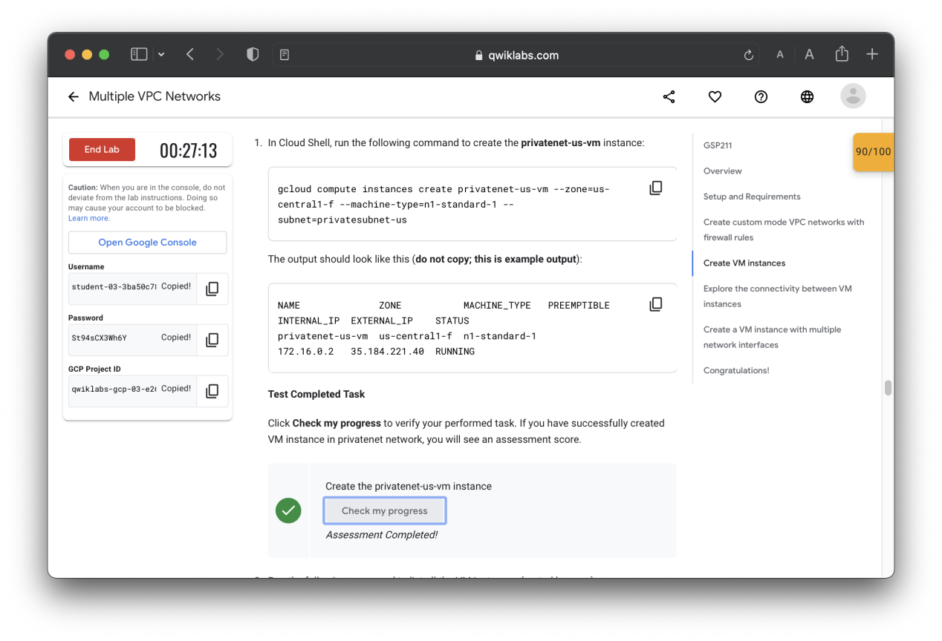

**Lab report screen-shot #14:**

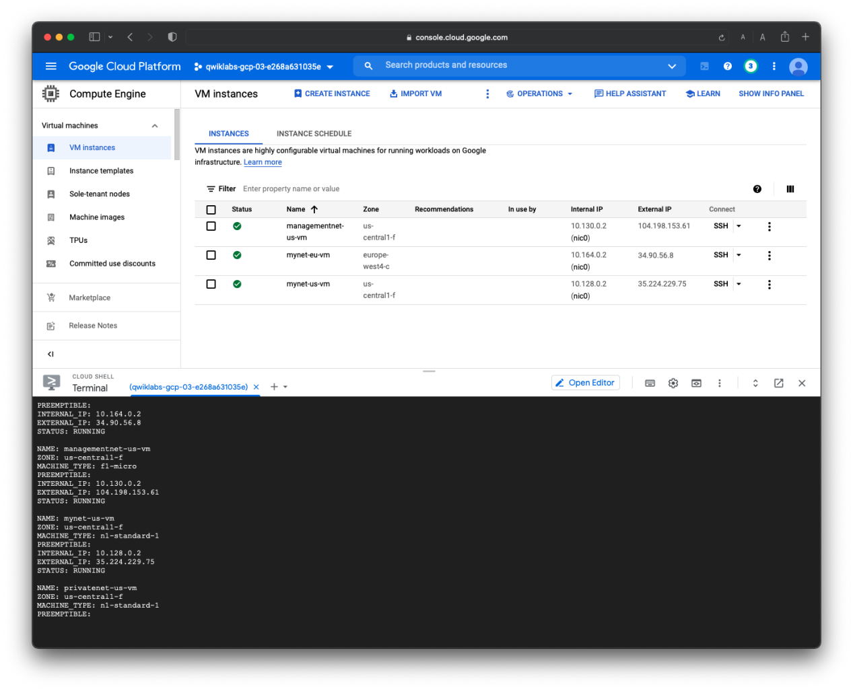

**Lab report screen-shot #15:**

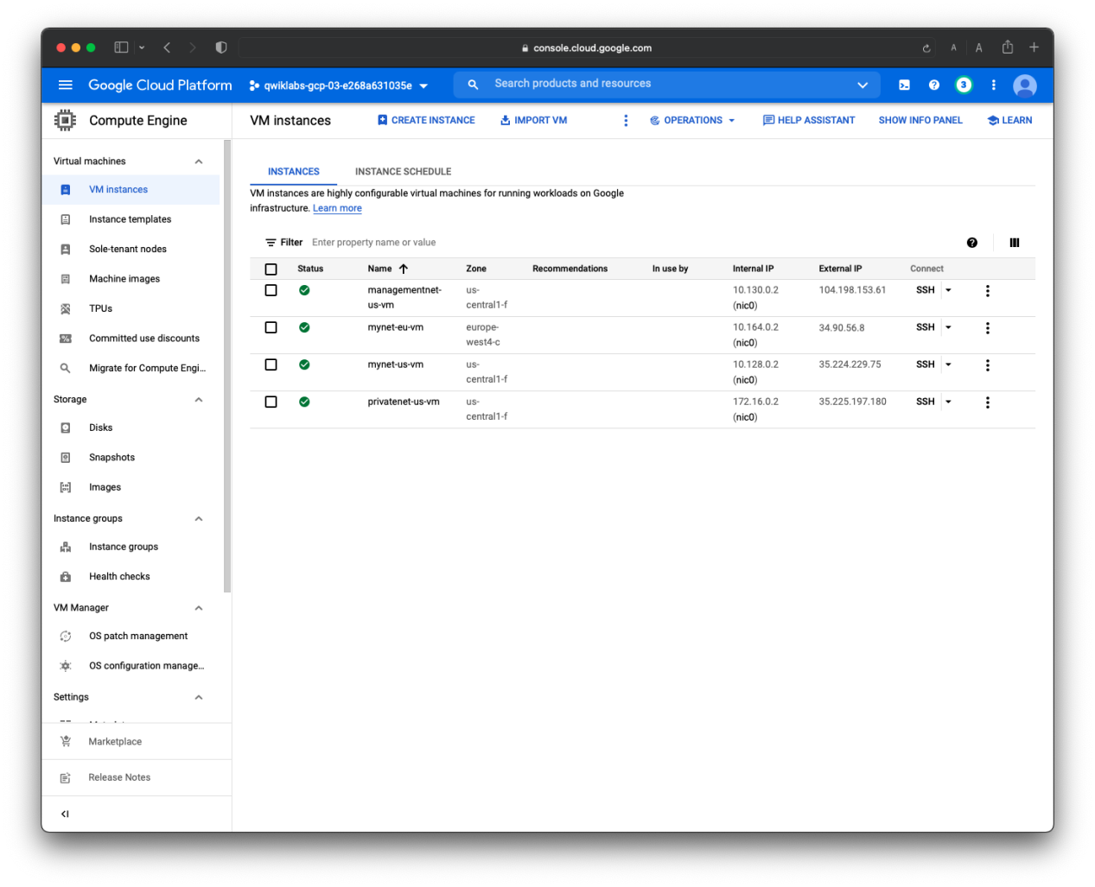

**Lab report screen-shot #16:**

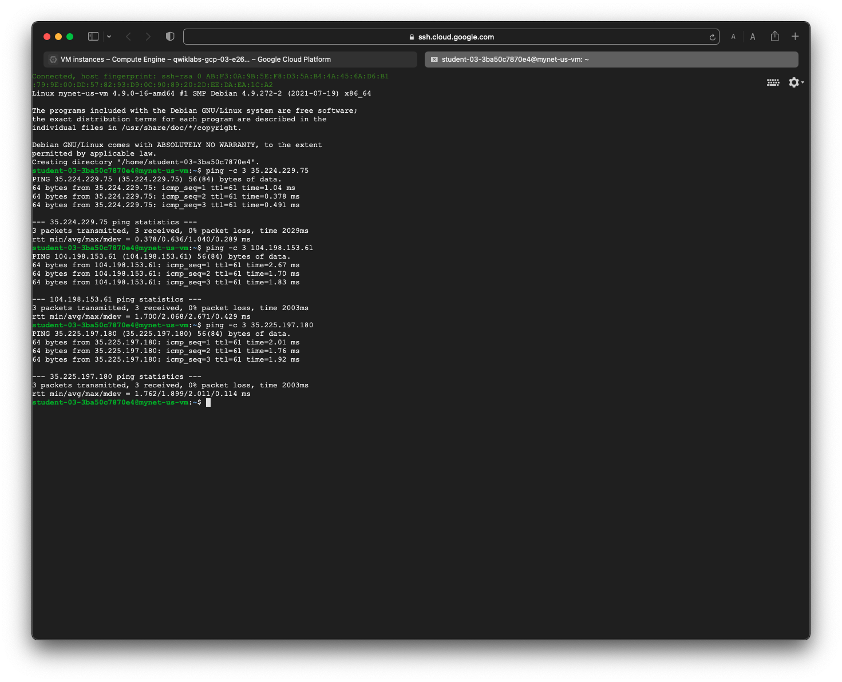

**Lab report screen-shot #17:**

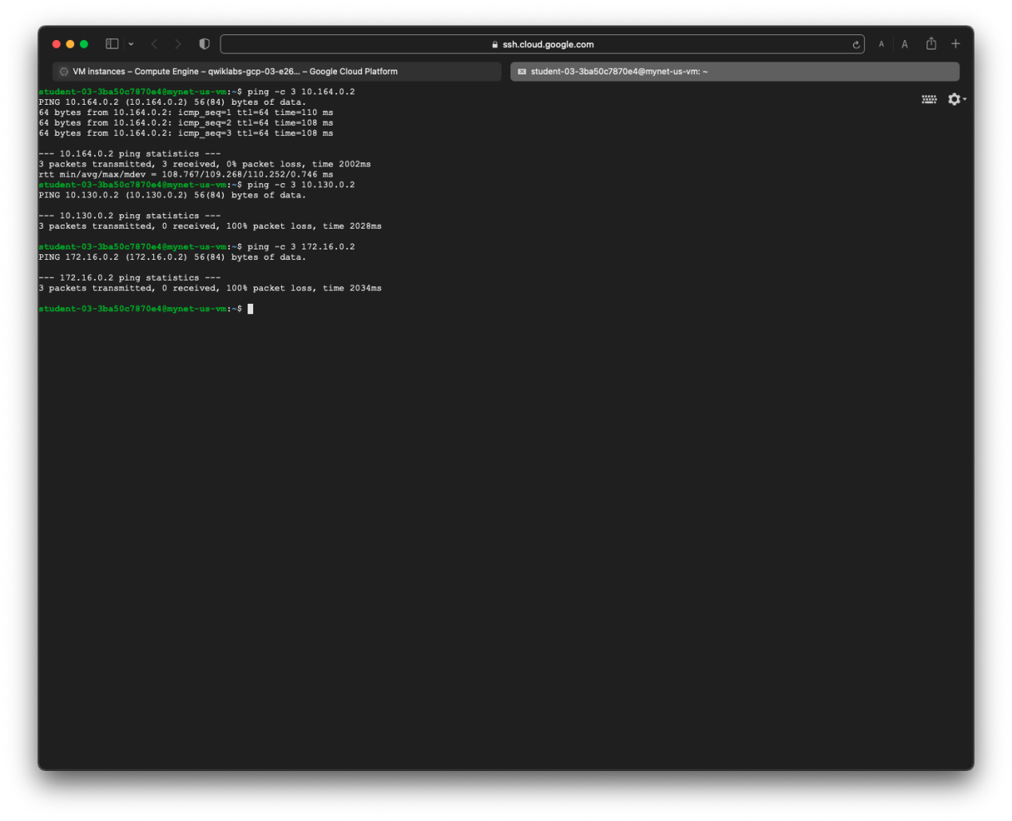

**Lab report screen-shot #18:**

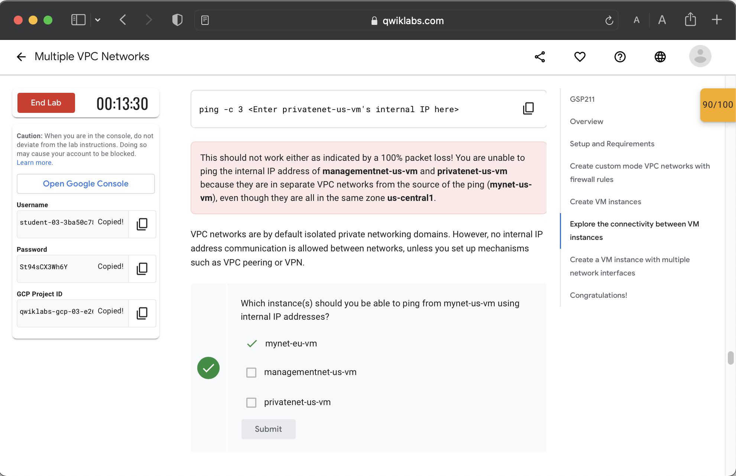

**Lab report screen-shot #19:**

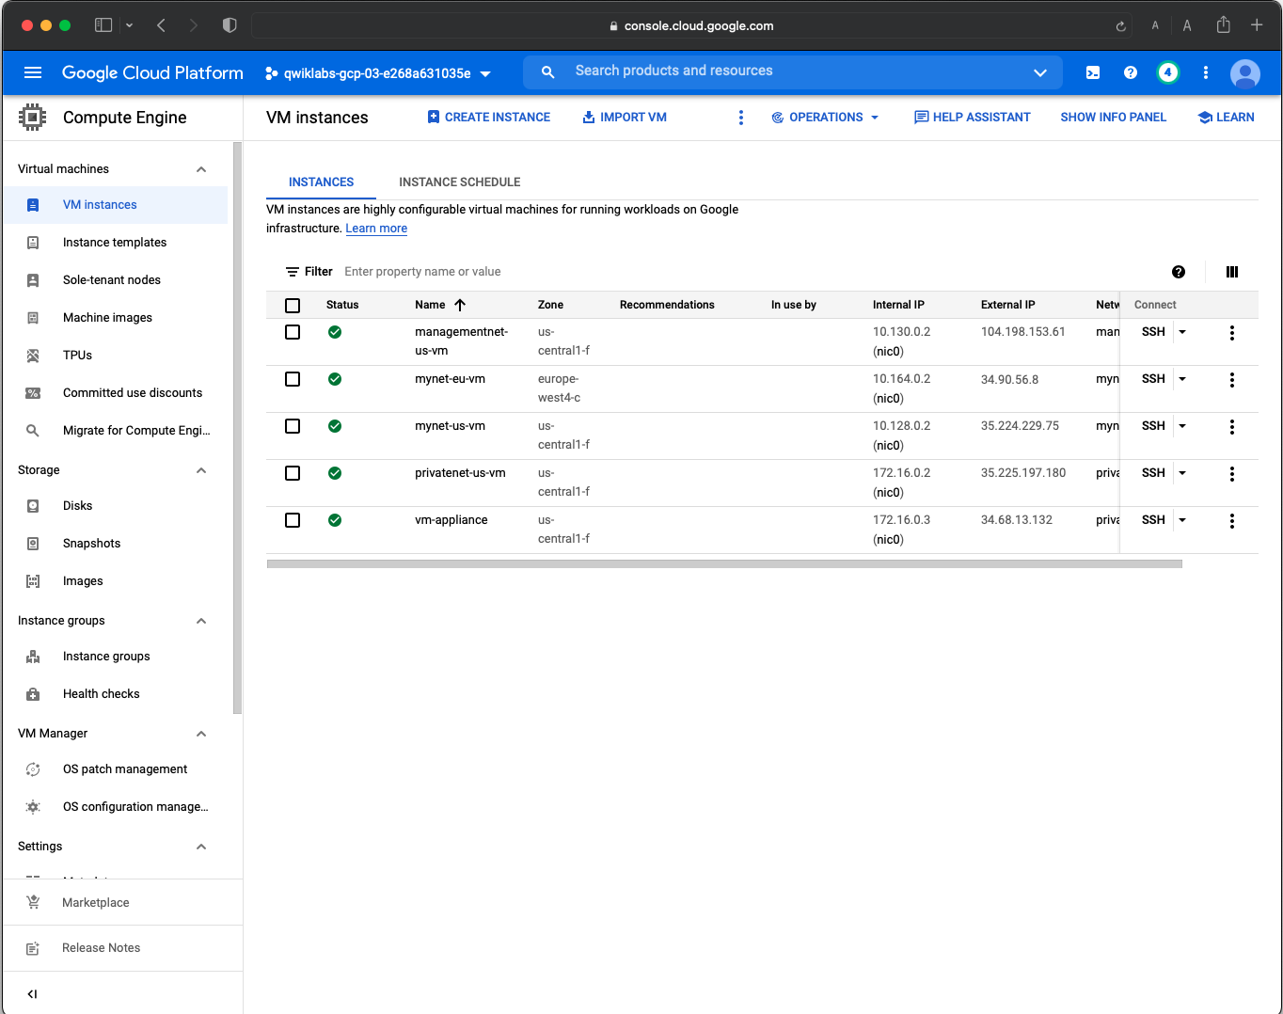

**Lab report screen-shot #20:**

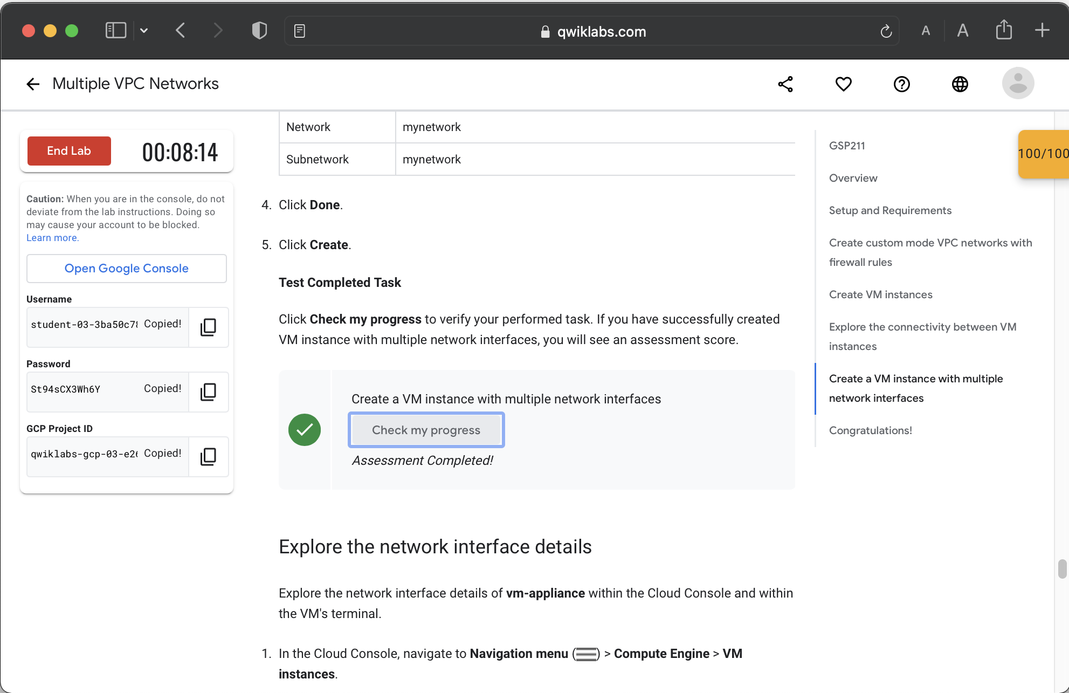

**Lab report screen-shot #21:**

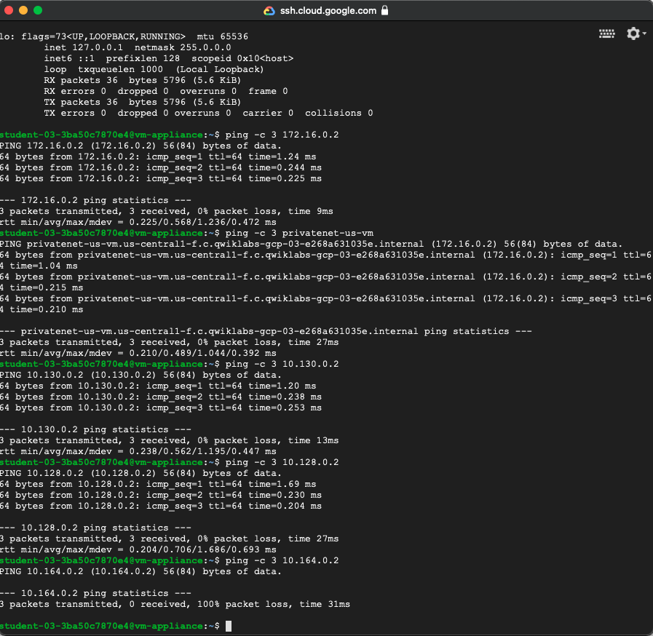

**Lab report screen-shot #22:**

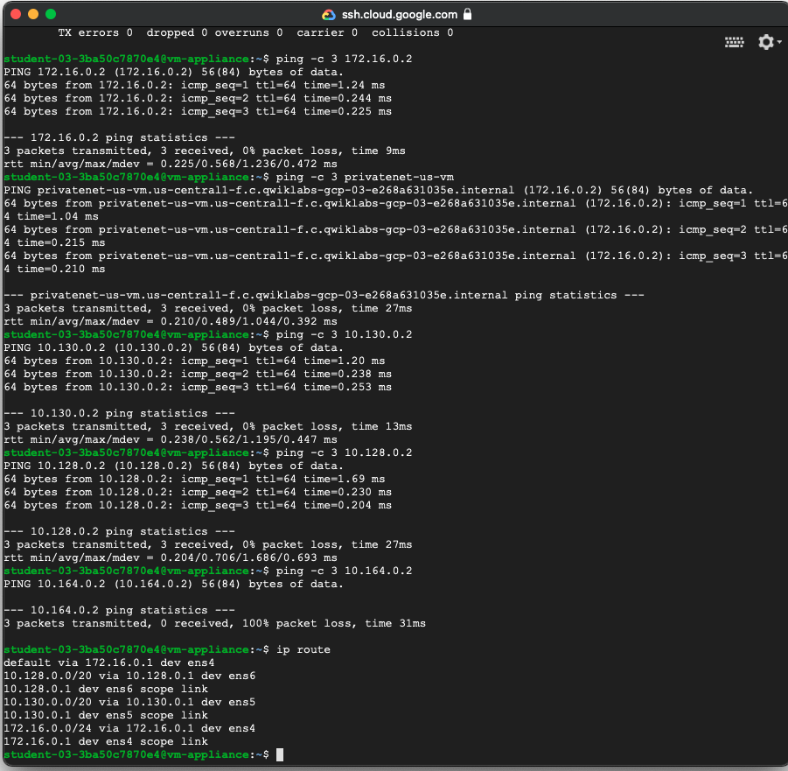

**Lab report screen-shot #23:**

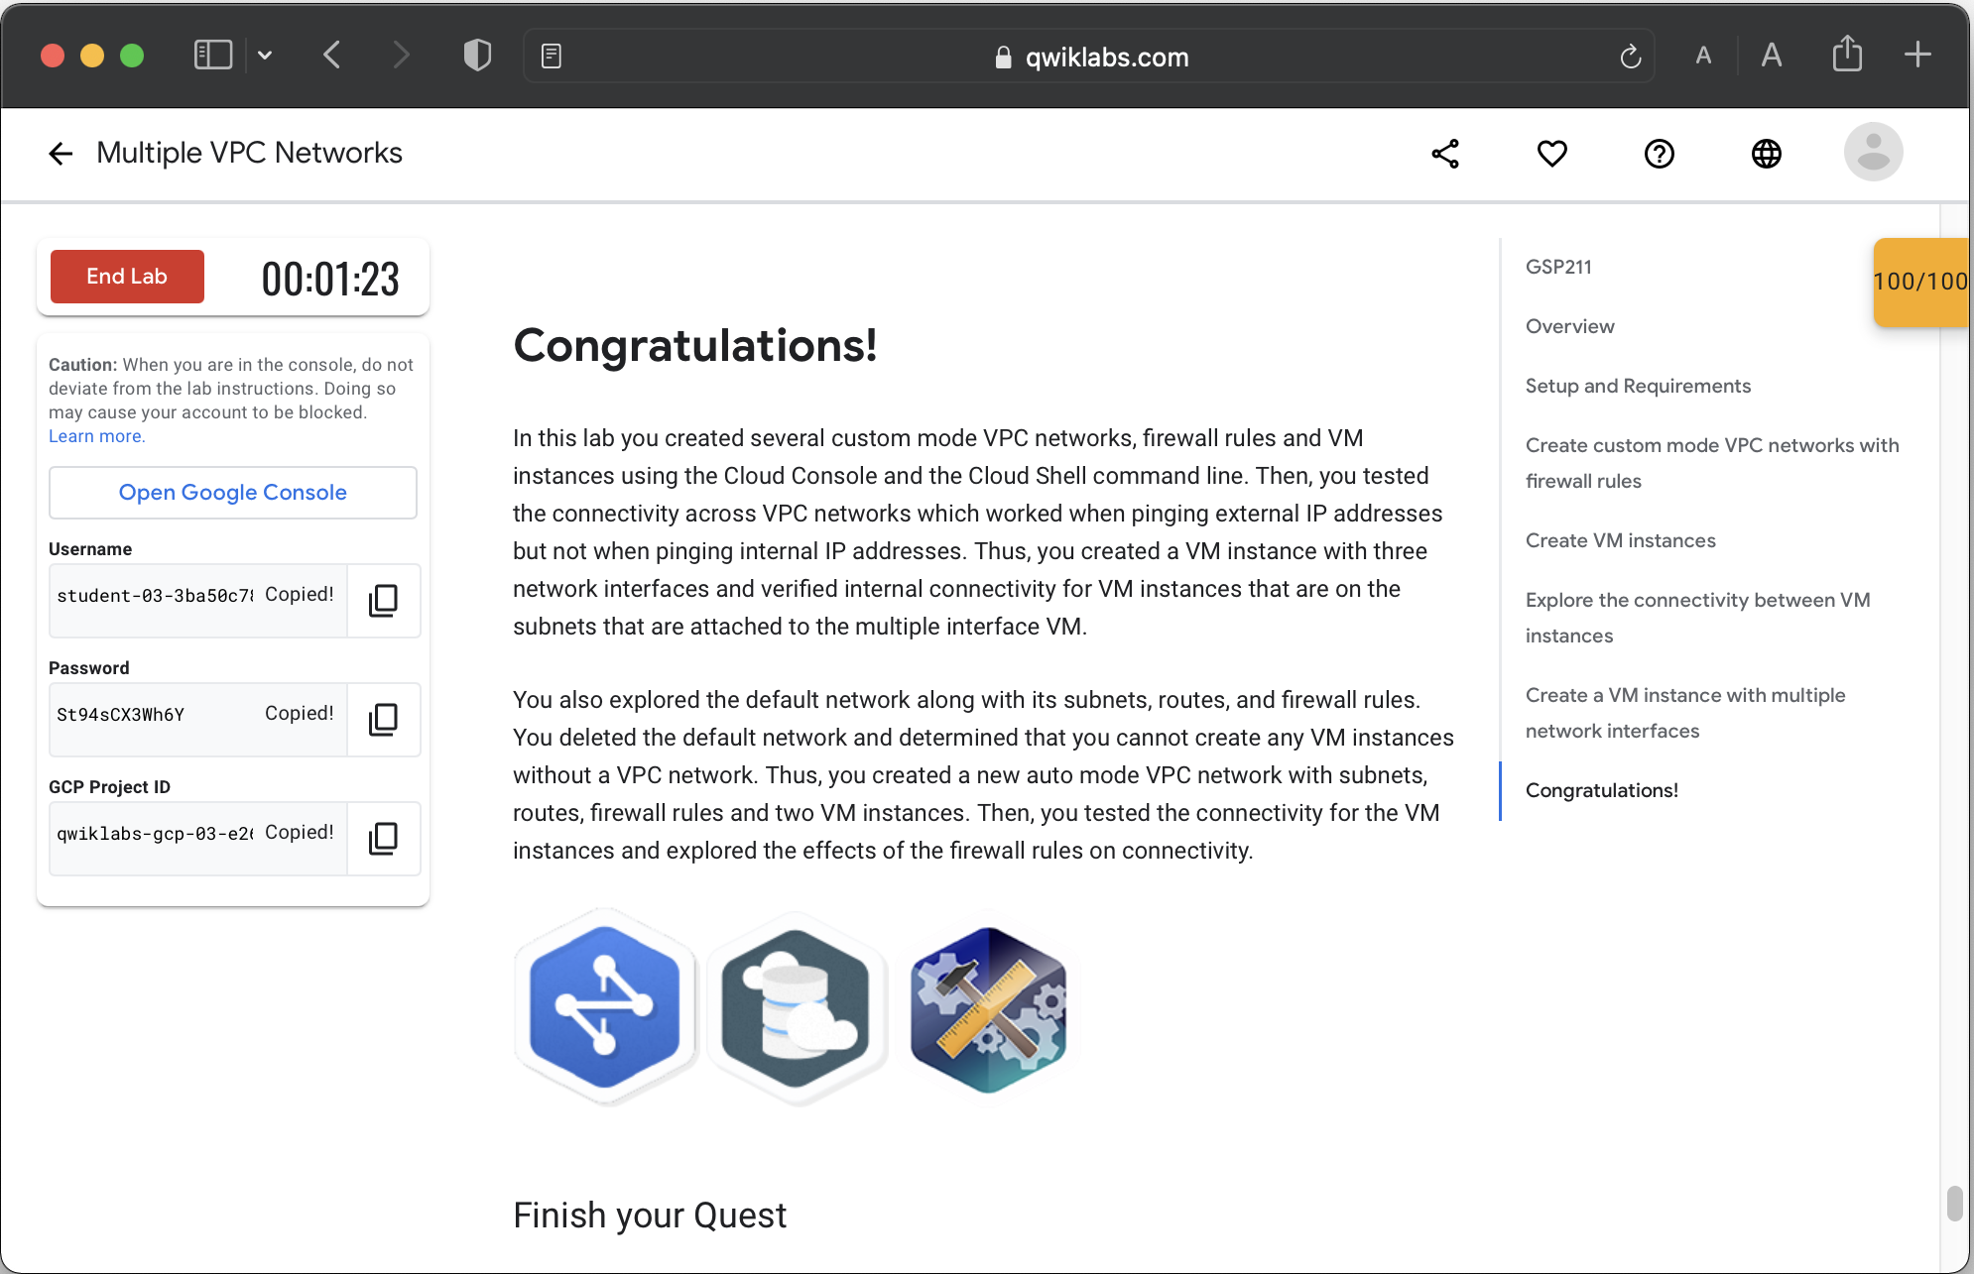

Exercise 2: Load Balancing.

**Lab report screen-shot #24:**

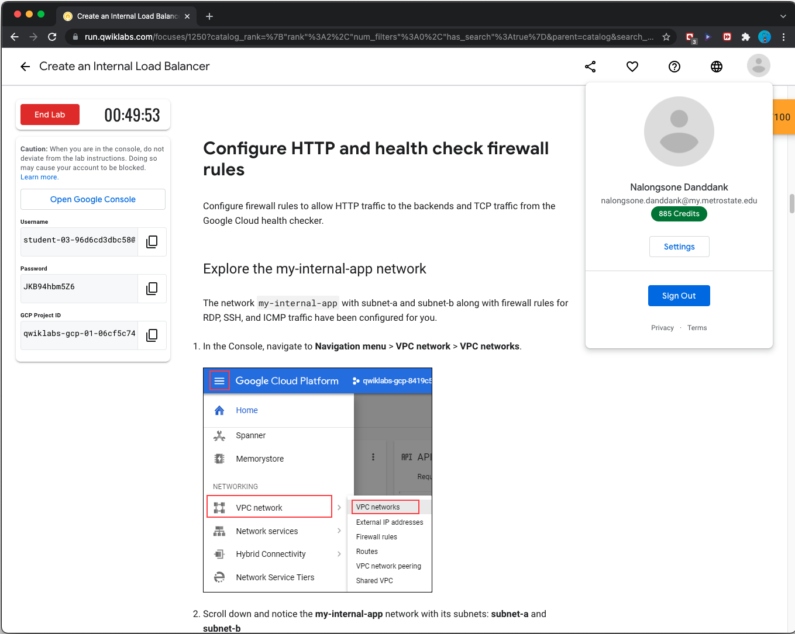

**Lab report screen-shot #25:**

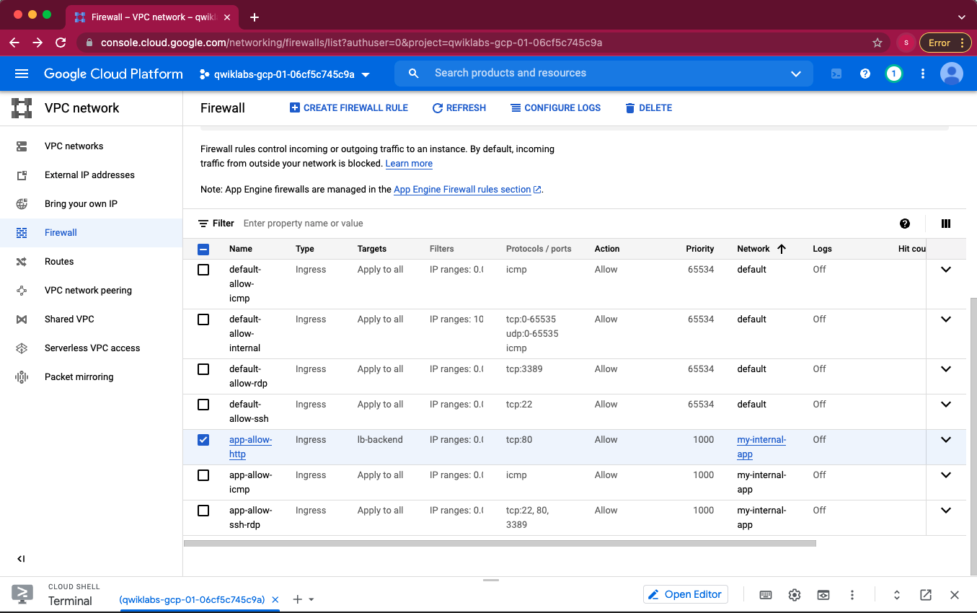

**Lab report screen-shot #26:**

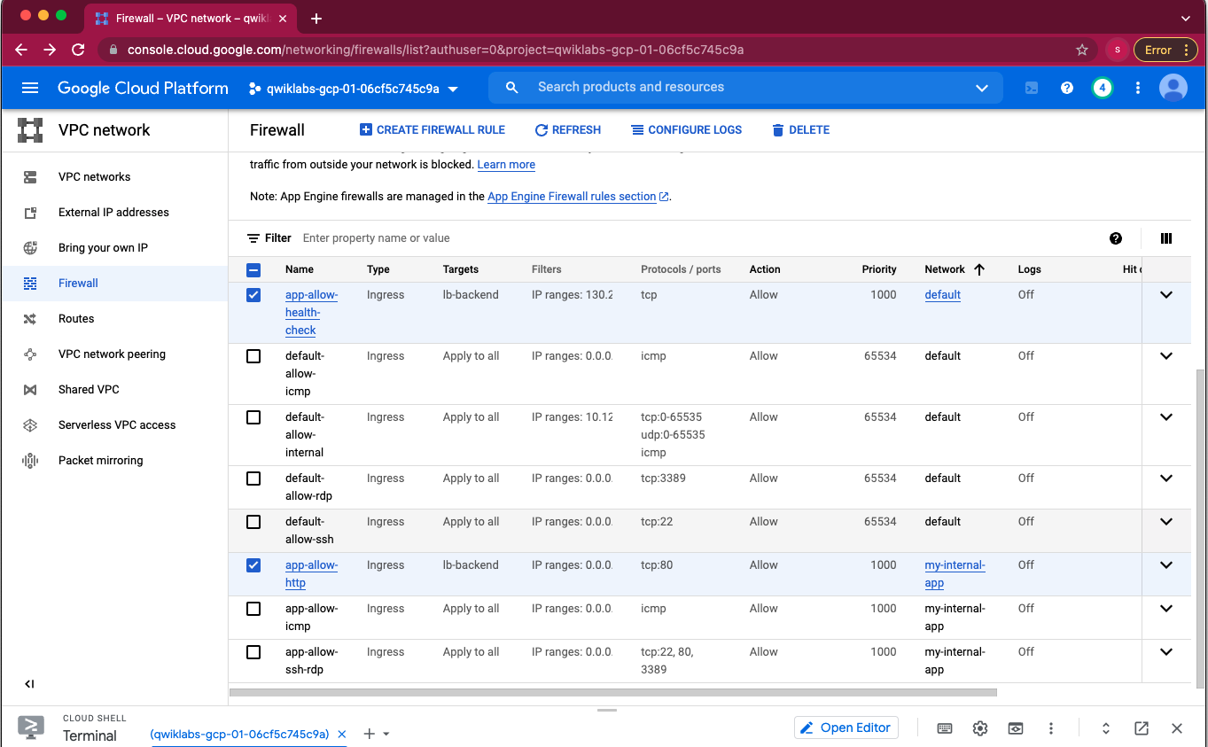

**Lab report screen-shot #27:**

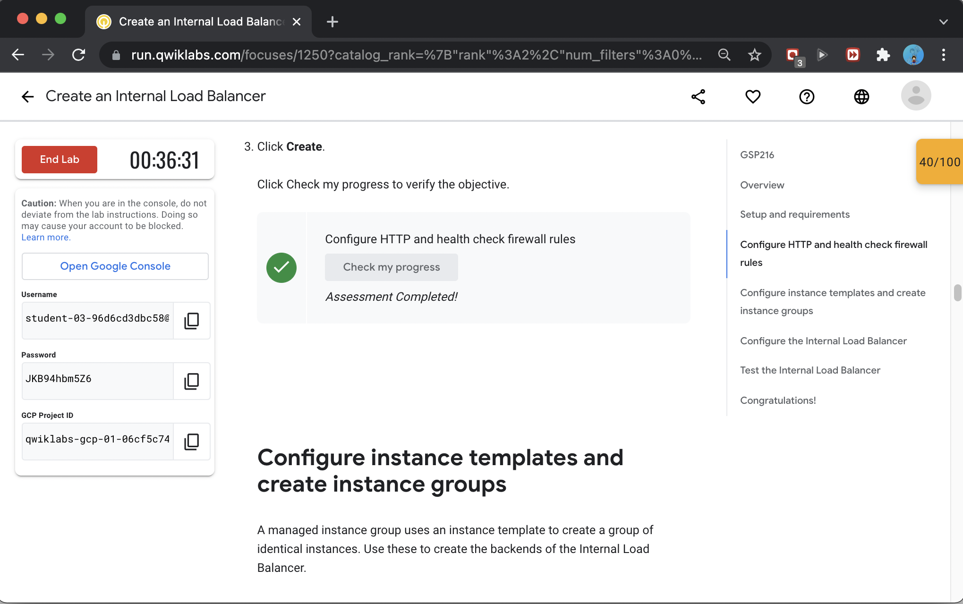

**Lab report screen-shot #28:**

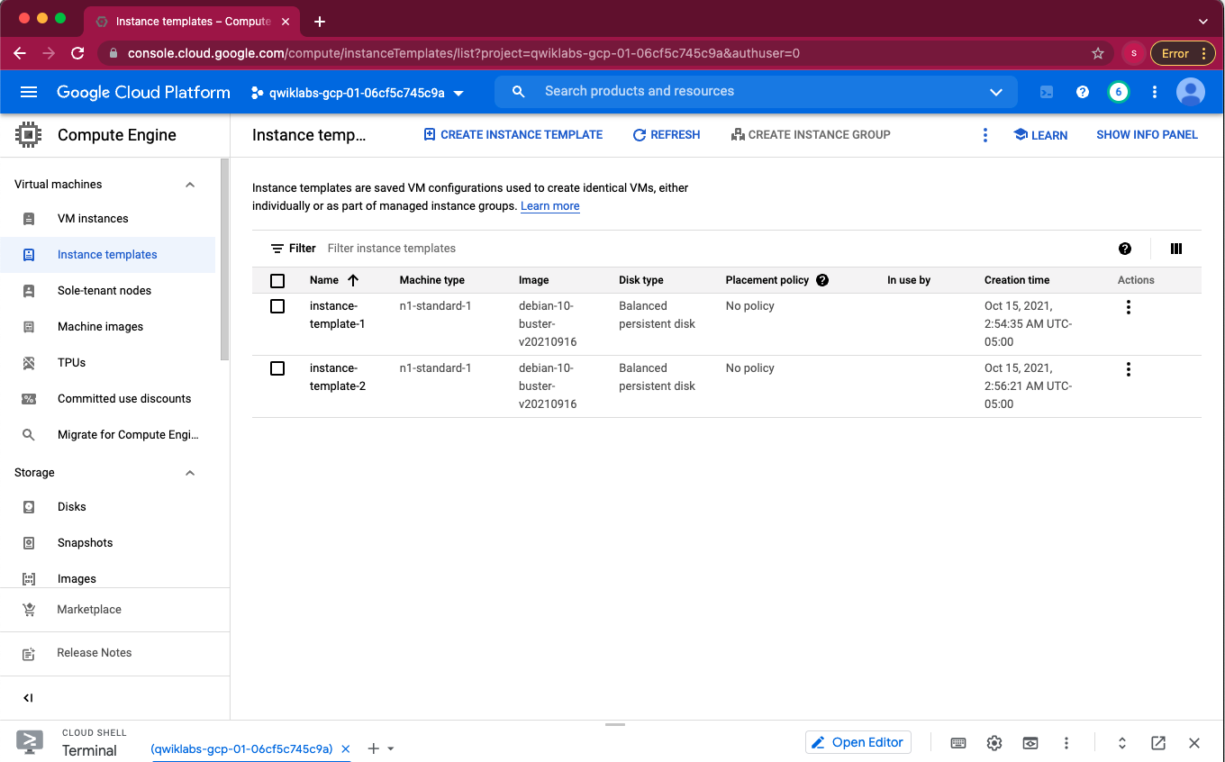

**Lab report screen-shot #29:**

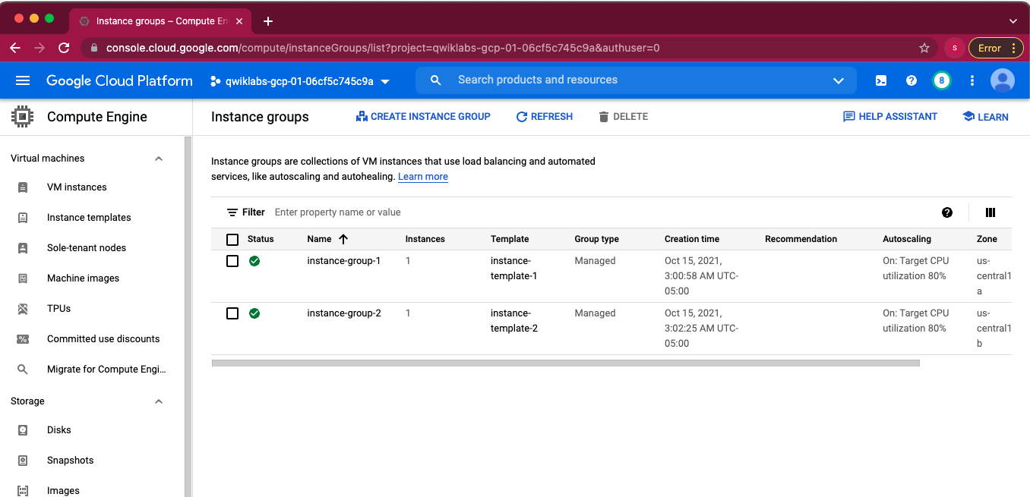

**Lab report screen-shot #30:**



**Lab report screen-shot #31:**

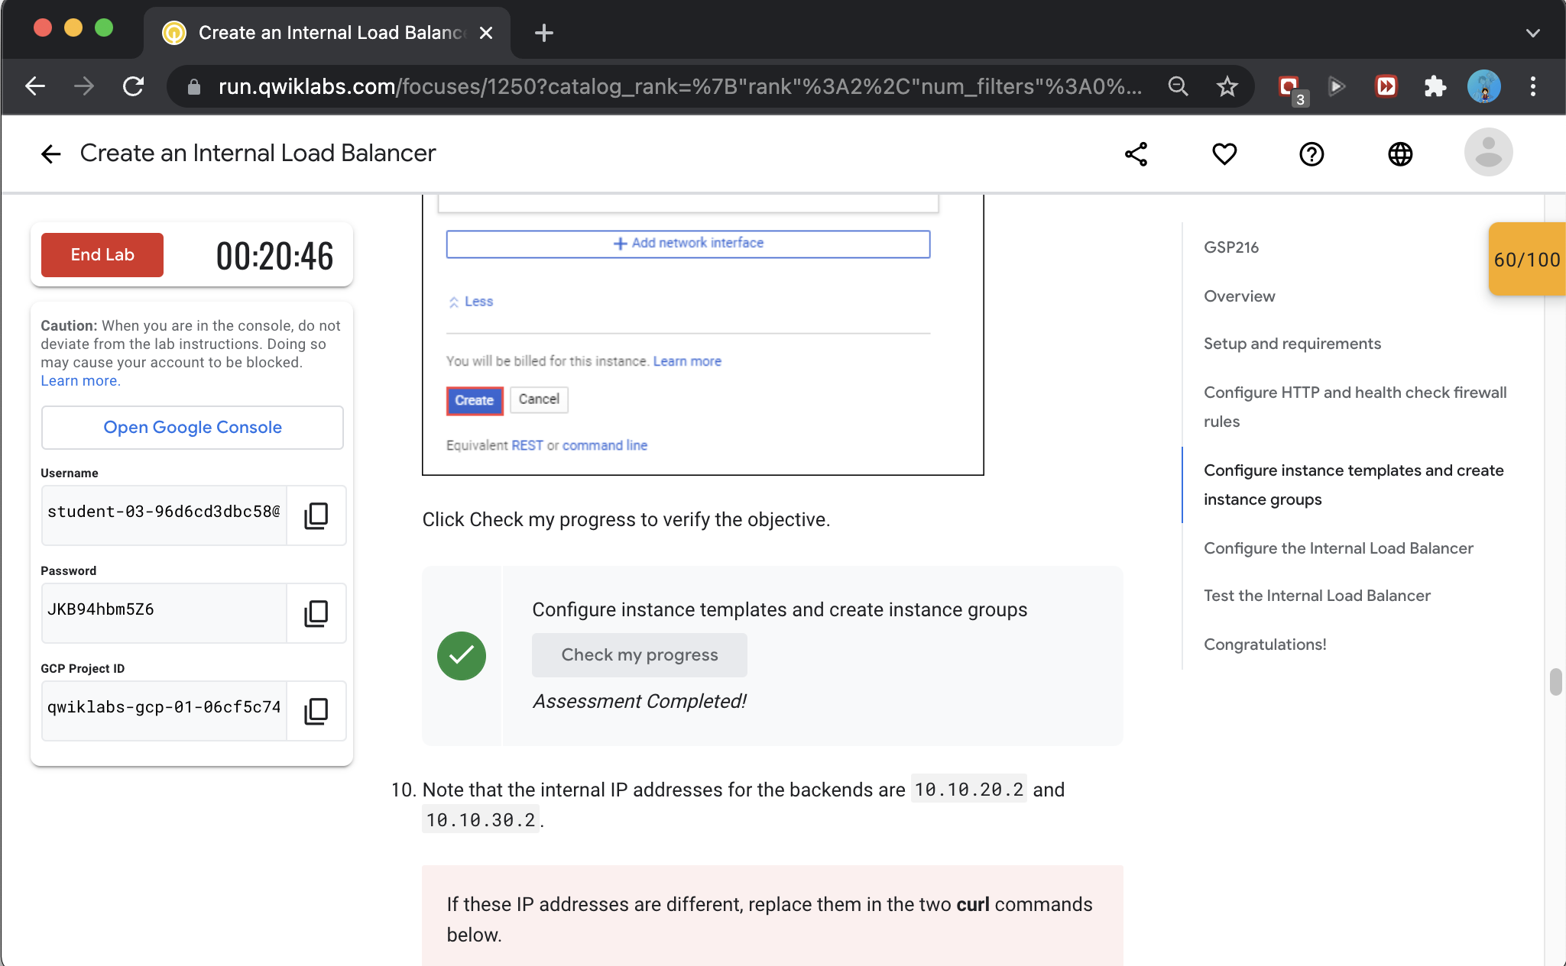

**Lab report screen-shot #32:**

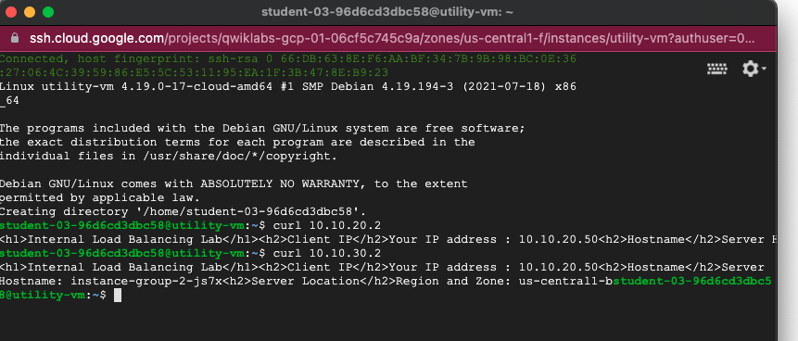

**Lab report screen-shot #33:**

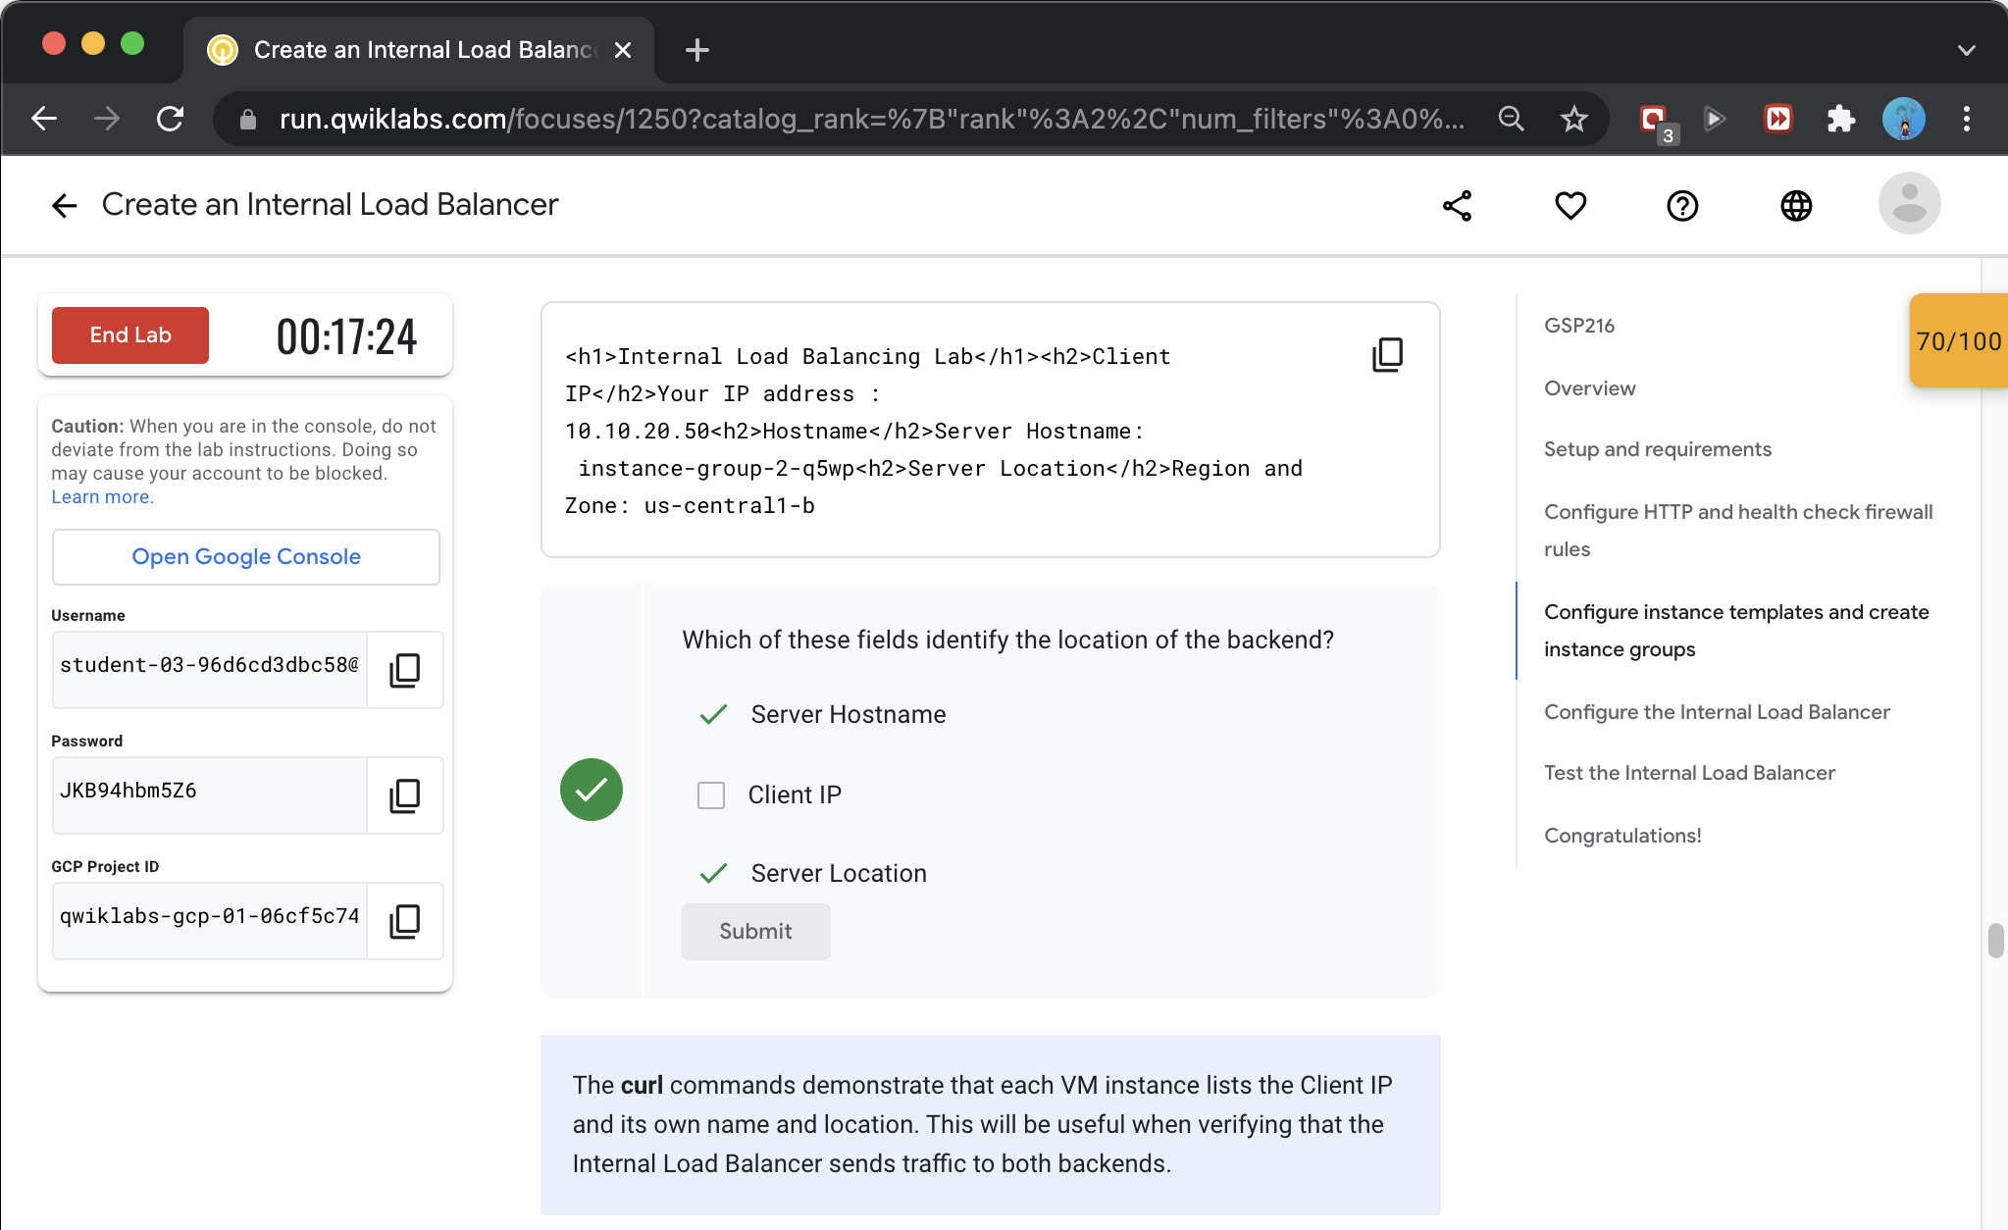

**Lab report screen-shot #34:**

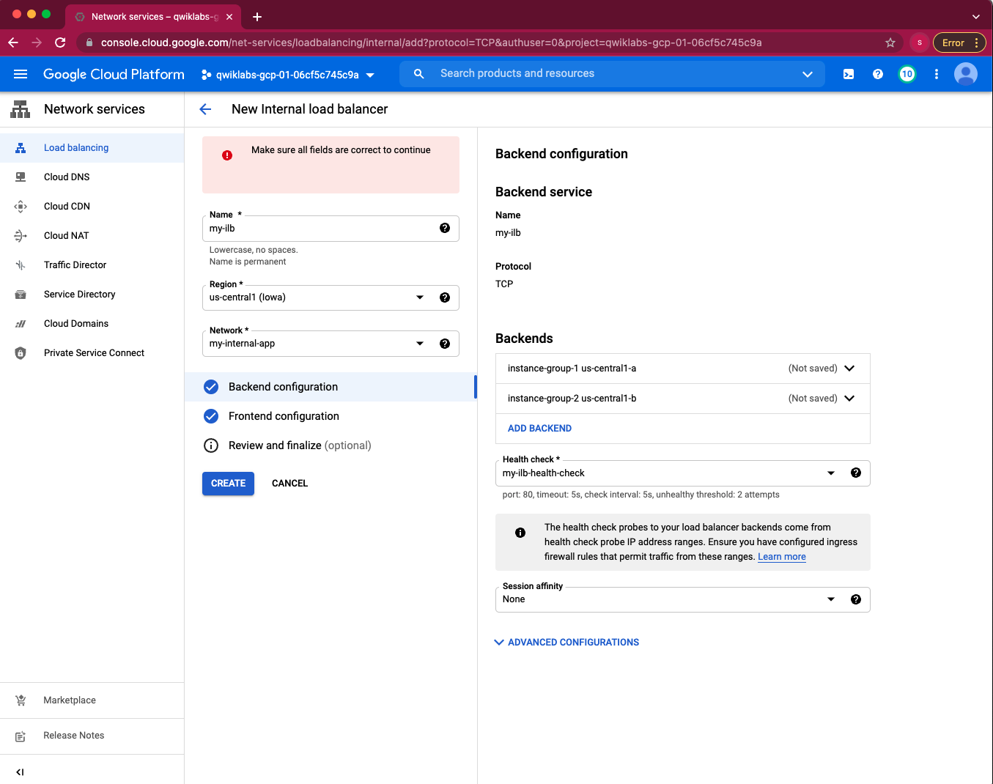

**Lab report screen-shot #35:**

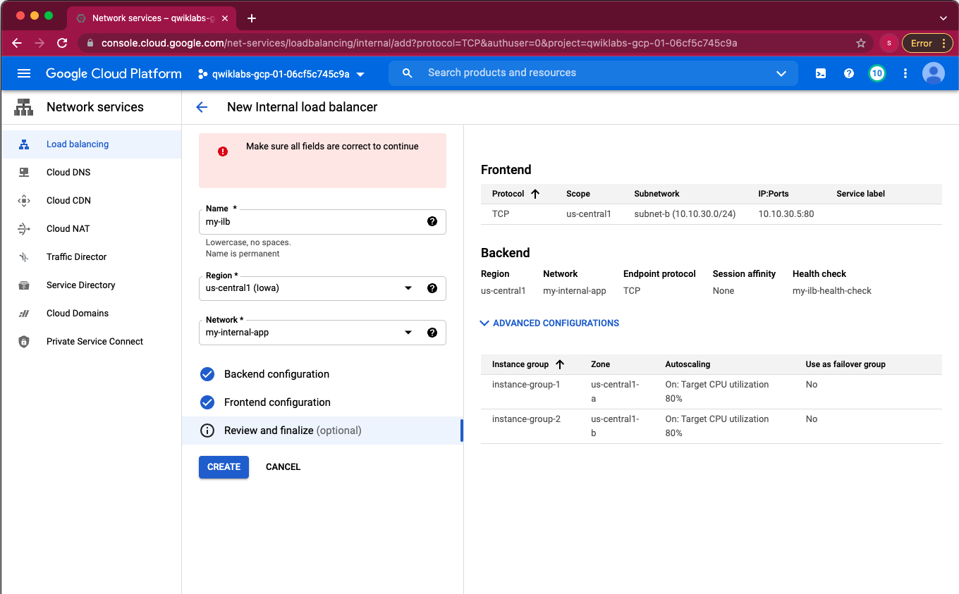

**Lab report screen-shot #36:**

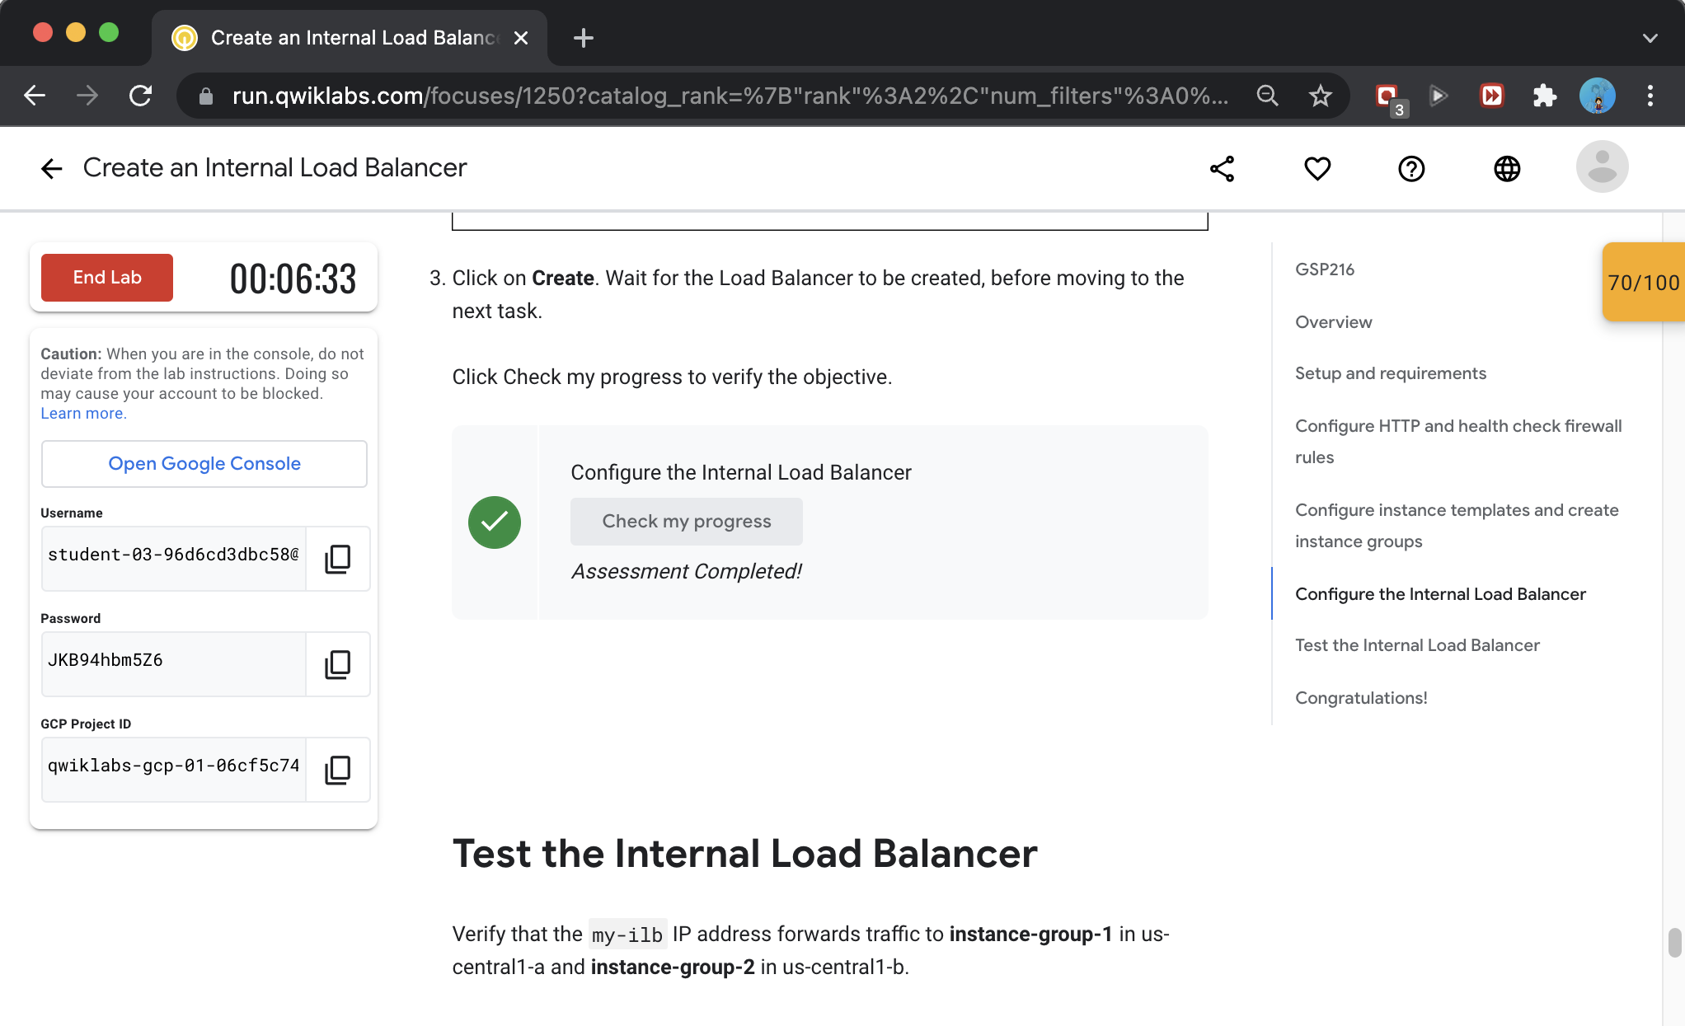

**Lab report screen-shot #37:**

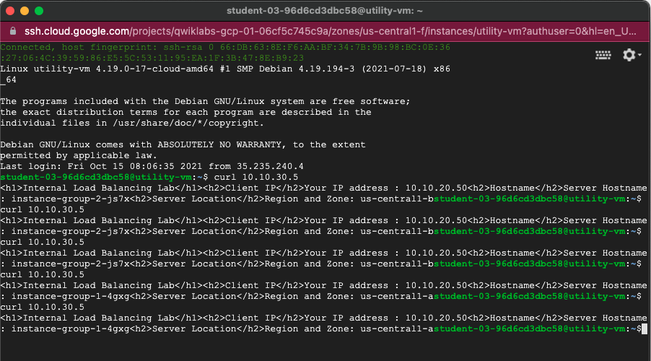

**Lab report screen-shot #38:**

